Software Requirement Specifications
<AI-Based Quran Tajweed Learning and Practice Platform>



Submitted by
<Amna Azam (F22BINFT1E02069)>

Submitted to
<Sir Zaman Ali>

Department of Information Technology
Faculty of Computing
The Islamia University of Bahawalpur

Summary
This document is about the Online Quran Tajweed Learning Platform, a web-based system designed to help people learn the Quran and follow the correct Tajweed rules. The platform is built for anyone who wants to improve their Quranic recitation, whether they are complete beginners or already have some experience. It makes learning very easy and accessible because users can study from anywhere and at any time, without needing to go to a physical class. The main goal is to help learners pronounce words correctly, understand the rules of Tajweed, and practice regularly to improve step by step. The platform combines lessons, audio, practice exercises, and progress tracking all in one place, which makes learning organized and effective.
Users start by creating an account and logging in to access their own dashboard. From there, they can select lessons based on their level, difficulty, or area they want to focus on. Each lesson includes professional audio recitations that users can listen to and repeat to improve their pronunciation. There are also exercises designed to help learners practice specific Tajweed rules. Users can record their own recitations, and the platform uses AI-powered speech recognition to analyze their pronunciation. The system detects errors, highlights them, and provides instant feedback, helping learners improve their Tajweed accuracy. This interactive practice is very helpful because it lets learners improve at their own pace and repeat lessons until they feel confident. The platform also shows users their progress, including which lessons they have completed, scores from exercises, and areas where more practice is needed. This motivates learners and gives them a clear idea of how much they are improving over time.
On the administrative side, the platform provides tools for teachers or admins to manage the system efficiently. They can upload new lessons and audio files, update existing content, and organize everything in a structured way so learners can find what they need easily. Admins can also manage student accounts, track their participation, and generate reports to see how each learner is doing. This allows them to provide guidance and support where needed. The system ensures that both learners and administrators can use it easily, securely, and without confusion.
The platform is designed to be simple but very effective. It not only helps users learn and practice Tajweed rules but also encourages them to stay consistent and motivated. By combining listening, repetition, recording, and progress tracking, learners get a full experience that helps them improve faster and more accurately. At the same time, admins have everything they need to manage lessons, support students, and keep the system running smoothly. Overall, the Online Quran Tajweed Learning Platform makes learning Tajweed accessible, interactive, and reliable, giving learners the chance to improve their recitation and teachers the tools to support them in the best way possible.

Table of Contents

Summary…………………………………………………………………………………2

Table of Contents………………………………………………………………………..4

1. Introduction…………………………………………………………………………..6
1.1 Purpose……………………………………………………………………………6
1.2 Scope………………………………………………………………………………6
1.3 Product Perspective………………………………………………………………7
1.4 User Characteristics………………………………………………………………7
1.5 Similar Apps and Systems / Literature Review…………………………………7
1.6 Proposed Technologies……………………………………………………………8

2. Requirements…………………………………………………………………………8
2.1 Functional Requirements…………………………………………………………8
2.1.1 Sign Up (FR001)……………………………………………………………8
2.1.2 Login (FR002)………………………………………………………………9
2.1.3 Lesson Selection & Audio Playback (FR003)……………………………9
2.1.4 Pronunciation Practice (FR004)……………………………………………9
2.1.5 Progress Tracking (FR005)………………………………………………10
2.1.6 Lessons & Audio Management (FR006)…………………………………10
2.1.7 User Management (FR007)………………………………………………10
2.2 Non-Functional Requirements…………………………………………………..11

3. Use Cases and Flow of Processes…………………………………………………12
3.1 UC001 – Sign Up…………………………………………………………………13
3.2 UC002 – Login……………………………………………………………………14
3.3 UC003 – Browse Lessons………………………………………………………..15
3.4 UC004 – Play Lesson Audio……………………………………………………..16
3.5 UC005 – Pronunciation Practice…………………………………………………17
3.6 UC006 – Track Progress…………………………………………………………18
3.7 UC007 – Add New Lessons (Admin)……………………………………………19
3.8 UC008 – Manage Users (Admin)………………………………………………20
3.9 UC009 – Monitor System Activity (Admin)……………………………………21

4. Activity Diagrams……………………………………………………………………22
UC001 Signup……………………………………………………………………..22
UC002 Login………………………………………………………………………23
UC003 Browse Lessons…………………………………………………………..24
UC004 Play Lesson Audio……………………………………………………….25
UC005 Pronunciation Practice……………………………………………………26
UC006 Track Progress……………………………………………………………27
UC007 Add New Lessons………………………………………………………..28
UC008 Manage Users…………………………………………………………….29
UC009 Monitor System Activity………………………………………………….30

5. References……………………………………………………………………………31

- Introduction
Online Quran Tajweed Learning Platform is being developed to provide a web-based environment where learners can study the Quran with correct Tajweed rules. The platform is designed to help users improve their recitation skills, whether they are beginners or already have some knowledge of Tajweed. The system will allow learners to access structured lessons, listen to professional recitations, practice pronunciation, and track their progress over time. This project focuses on developing modules that provide lesson selection, audio playback, pronunciation practice, and progress tracking. The system also includes administrative tools to manage lessons, audio files, and user accounts, ensuring the platform runs efficiently and supports both learners and teachers.
  - Purpose
The main goal of this project is to provide an accessible, interactive, and organized platform for learning Quranic recitation with proper Tajweed. The objectives include helping users learn and practice Tajweed rules, providing audio guidance for correct pronunciation, allowing learners to track their progress, and giving administrators tools to manage lessons and monitor learners’ performance. The project aims to make Quran learning convenient for anyone, anywhere, while improving the quality and effectiveness of online Quran education.
  - Scope
The platform will include features such as user registration and login, lesson selection, audio playback for recitation, interactive exercises for practicing Tajweed, and progress tracking dashboards. On the admin side, the system will allow lesson management, audio content uploads, user account management, and performance tracking. Features that are out of scope include live video classes, offline access without internet, and integration with third-party learning apps or payment systems. The main focus is on Tajweed learning with audio-based lessons and progress monitoring.
  - Product Perspective
The developed module will be the main learning system for users and will act as a central platform for Quranic lessons. It will fit into the system by providing a structured way to access lessons, practice recitation, and track progress. The administrative module ensures smooth management of content and user data, making the system complete and easy to use. The platform will act as a self-contained web application but can be extended later with additional modules, such as quizzes, gamification, or mobile access.

  - User Characteristics
The main users of the system are learners who want to study Quranic recitation online. They may range from beginners with no prior knowledge to advanced learners practicing Tajweed rules. Other users include administrators or teachers who manage lessons, audio files, and monitor learners’ progress. Users are expected to have basic computer literacy, access to the internet, and a device capable of playing audio. Learners interact mainly with lessons, exercises, and progress tracking dashboards, while admins interact with management tools and reporting features.

  - Similar apps and systems/Literature Review
There are several online Quran learning apps and platforms available. Some of the top Tajweed platforms I visited were made using JavaScript frameworks, which caused the websites to refresh frequently, making the user experience less smooth. Some platforms were not even fully functional, with pages not loading properly or certain features not working as expected. Others lacked interactivity, meaning users could not practice their pronunciation or get feedback on their recitation. Most existing platforms provide audio recitations or video lessons, but they often do not include structured progress tracking or interactive exercises for Tajweed. Some also require paid subscriptions for full access. The main shortcomings of these platforms are limited interactivity, technical issues like constant page refreshes, lack of personalized feedback, and poor user experience in general. My proposed system aims to address these problems by providing a smooth, interactive, and fully functional platform with audio-based lessons, guided exercises, and progress tracking that works reliably without unnecessary page reloads.

  - Proposed Technologies
The system will be web-based and will use technologies suitable for interactive learning platforms. For the frontend, React will be used to create a responsive and dynamic user interface. For the backend, Node.js with Express will handle server-side logic and API management. The database will use MongoDB to store user data, lesson details, audio file metadata, and progress tracking information. Audio playback and recording features will be implemented using web APIs. For pronunciation feedback, Python libraries such as SpeechRecognition or Whisper API will be used to perform AI-based speech analysis, converting user recitation into text and comparing it with the correct Quranic text to detect pronunciation errors.

- Requirements
The Online Quran Tajweed Learning Platform is designed to provide users with a structured and interactive environment to learn Quranic recitation with correct Tajweed rules. The system allows learners to sign up, log in, browse and select lessons, listen to professional audio recitations, practice pronunciation, record their own recitations, and track their learning progress. Administrators can manage lessons, upload audio content, monitor users’ performance, and provide guidance where needed. The platform aims to make learning Tajweed simple, engaging, and accessible for users worldwide while giving administrators the tools to maintain and manage the system effectively.
  - Function Requirements
    - Sign Up
- Name: FR001
- Purpose: Sign up process is required for a user to become the member of system.
- User(s): Learner, Admin
- Input:
  - Name: Actual name of user
  - Email: Valid email address
  - Password: Must be 8 characters long and must include number
  - Profile Picture: Optional display picture
  - Approval from Admin: Admin verifies user registration if needed
- Output: User becomes a registered member and can able to login

    - Login
- Name: FR002
- Purpose: Allows registered users to access their account.
- User(s): Learner, Admin
- Input:
  - Email/Username
  - Password
- Output: User gains access to the dashboard and relevant features

    - Lesson selection and Audio playback
- Name: FR003
- Purpose: Allows users to select lessons and listen to Quranic recitations
- User(s): Learner
- Input:
  - Lesson choice (by topic, or sequence)
- Output: Selected lesson plays audio; user can repeat or pause playback

    - Pronunciation Practice
- Name: FR004
- Purpose: Enables user to practice recitation and get feedback
- User(s): Learner
- Input:
  - Recorded recitation by user
- Output: Feedback generated by an AI speech recognition model, indicating correctly pronounced words, mispronunciations, and suggestions for improvement. The system visually highlights incorrect words in red and provides guidance to the user.

    - Progress Tracking
- Name: FR005
- Purpose: Tracks user progress across lessons and exercises
- User(s): Learner, Admin
- Input:
  - Completed Lessons
  - Scores from exercises
- Output: Visual progress report, percentage of course completed, improvement tracking
    - Lessons and Audio Management
- Name: FR006
- Purpose: Allows admin to manage lessons and audio content
- User(s): Admin
- Input:
  - Upload new Lessons or audio files
  - Edit existing lessons
  - Remove outdated content
- Output: Lessons updated and ready for learners

    - User Management
- Name: FR007
- Purpose: Allows admins to monitor and manage learner’s accounts
- User(s): Admin
- Input:
  - User details
  - Account status updates
- Output: Active and updated user accounts; ability to provide guidance

  - Non-Functional Requirements
• Performance: The platform must load lessons and audio within 3 seconds and support at least 1000 concurrent users without lag.
• Usability: The system should have a simple and intuitive interface so that learners of all ages can use it easily.
• Security: User data, including personal information and recitation recordings, must be securely stored and protected from unauthorized access. Passwords must be encrypted.
• Reliability: The platform should have a 99% uptime, with minimal crashes or errors.
• Accessibility: The system must be compatible with major web browsers and devices (PC, tablets, and mobile phones).
• Scalability: The platform should be designed so that new lessons, audio files, and users can be added without affecting system performance.
• Maintainability: Administrators should be able to update lessons, manage users, and perform routine maintenance easily.

- Use Cases and Flow of Processes
The use case diagram shows the main interactions between the two primary actors of the system: the User and the Admin. It presents how each actor communicates with the system and what types of actions they can perform. The purpose of this diagram is to provide a clear and high-level understanding of the system behavior by illustrating all the important features as use cases.
On the left side of the system, the User is shown as the main actor who interacts with the platform to learn Tajweed. The diagram highlights the basic and essential functions the User needs, such as creating an account through the Sign Up process and later accessing the platform through Login. After logging in, the User can browse the lessons that are available in the system. The Browse Lessons use case represents the user’s ability to go through different Tajweed topics. Users can also access the audio examples for every lesson through the Play Lesson Audio use case, which helps them listen to correct pronunciation and understand the rules properly.
Another important use case for users is the Pronunciation Practice, where they can record their own voice and compare it with the given audio to improve their recitation. Along with this, the system also allows users to keep track of their overall learning performance through the Track Progress use case. This helps them check which lessons they have completed and what areas still need improvement. All these user-related use cases show how the learner interacts with the Tajweed system in a simple and smooth way.
On the right side of the diagram, the Admin is shown as the second actor. The Admin handles the management and maintenance part of the system. Through the Add New Lessons use case, the admin can upload new Tajweed lessons, examples, and audio files. The Manage Users use case allows the admin to oversee user accounts, which includes viewing user information, resetting accounts if needed, and ensuring that the platform remains clean and controlled. The Admin also uses the Monitor System Activity use case to keep track of platform performance, user engagement, and overall activity inside the system. This helps in making decisions for improvements and future updates.
The diagram uses a system boundary titled “Tajweed Learning System” to clearly separate the internal functions of the platform from the outside actors. Every arrow from the actors points to a specific use case inside the system boundary, which shows that the action is initiated by the actor and then processed by the system. The layout of the diagram keeps the User on one side and the Admin on the other side so that both roles are visually separated and easy to understand.
Overall, the use case diagram provides a clear picture of how the different parts of the system work together. It shows what functions the system must perform, how the users will interact with it, and what responsibilities are handled by the admin. This helps in understanding the system requirements more clearly and serves as a guide for further design and development.
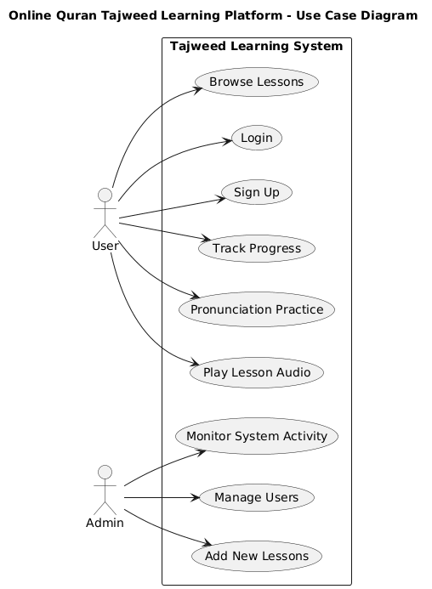
Figure 1: System Level Use Case Diagram

  - Use Case 1- Sign Up
ID | UC001
Name | Sign Up
Description | This use case describes the process flow for creating a new user account on the Online Quran Tajweed Learning Platform
Requirement(s) | FR001
Actor(s) | User
Precondition | The user must not already have an account in the system
Postcondition | A new user account is created, and the user receives confirmation that the account has been successfully registered.
Basic Flow | Basic Flow  - User enter sign-up details  - System validates all entered information  - Following fields are required  - Name  - Email  - Password  - System checks for valid formatting  - Email must be in correct format  - Password must be 8 character including number  - On successful validation the system will create a new user account  Alternative Flow  - Admin may create a new user manually from the Admin Dashboard  - Admin enters required user information  - System creates the user account and notifies the admin  Exceptions  - Invalid Inputs(wrong email format, weak password)  - Email already taken  - System unable to create account due to technical error
  - Use Case 2 - Login
ID | UC002
Name | Login
Description | This use case describes how a registered user accesses the Tajweed Learning Platform by entering valid credentials.
Requirement(s) | FR002
Actor(s) | User
Precondition | The user must already have a registered account
Postcondition | User is granted access to their dashboard
Basic Flow | Basic Flow  1. User enter email and password  2.System validates the credentials  2.1. Email must exist in database  2.2.Password must match stored password  3.On successful validation, system logs in user  4.System redirects user to dashboard  Alternative Flow  1.User selects “forgot password  2.User resets password and logs in again  Exceptions  - Wrong email or password  - Account not found  - System connection error
  - Use Case 3- Browse Lessons
ID | UC003
Name | Browse Lessons
Description | This use case describes how users view available Tajweed lessons arranged in levels or categories
Requirement(s) | FR003
Actor(s) | User
Precondition | User must be logged in
Postcondition | User is able to view lesson details and choose a lesson to study
Basic Flow | Basic Flow  - User opens lesson section  - System loads lesson into a list  - User selects a lesson to view details  Alternative Flow  - User applies filters (e.g; level, completed lessons)  - System shows filtered results  Exceptions  - Lessons fail to load due to server error  - Internet connection issue
  - Use Case 4 - Play Lesson Audio
ID | UC004
Name | Play Lesson Audio
Description | This use case describes how a user listens to example recitations for the selected Tajweed lesson.
Requirement(s) | FR004
Actor(s) | User
Precondition | User must have selected a lesson.
Postcondition | User listens to the audio and can replay it anytime.
Basic Flow | Basic Flow  - User opens a lesson.  - User clicks the play button.  - System loads the audio file.  - Audio starts playing.  5.User can pause, replay, or adjust playback.  Alternative Flow  1.User goes to next or previous audio example  2.System loads the new audio  Exceptions  - Audio files fail to upload  - Audio not available  - System audio playback error
  - Use Case 5 - Pronunciation Practice
ID | UC005
Name | Pronunciation Practice
Description | This use case describes how a user records their own recitation and practices Tajweed rules.
Requirement(s) | FR005
Actor(s) | User
Precondition | User must have selected a lesson with practice section
Postcondition | User successfully records their voice and reviews their practice
Basic Flow | Basic Flow  - User opens the practice section of the lesson.  - User presses the record button.  - System accesses microphone and starts recording.  - User completes recitation.  - System saves the recording temporarily.  - User plays their recorded audio.  - System uses AI-based speech recognition to analyze the recording, compares it with the correct recitation, highlights pronunciation mistakes, and provides suggestions.  Alternative Flow  1.User discards recording.  2.User records again.  Exceptions  - Microphone permission denied.  2.Recording failed.  3.Device does not support audio recording.
  - Use Case 6 - Track Progress
ID | UC006
Name | Track Progress
Description | This use case describes how a user views progress reports, completed lessons, and improvement areas
Requirement(s) | FR006
Actor(s) | User
Precondition | User must be logged in.
Postcondition | User gets updated performance metrics.
Basic Flow | Basic Flow  - User opens the progress section.  - System loads completed lessons.  - System loads practice scores or attempts.  - System displays progress graph or percentage.  - User reviews improvement areas.  Alternative Flow  - User clicks on any completed lesson.  - System opens that lesson again.  • Exceptions  - Progress data fails to load.  - No completed lessons recorded yet.
  - Use Case 7 - Add New Lessons (Admin)
ID | UC007
Name | Add New Lessons
Description | This use case describes how the admin uploads new Tajweed lessons and audio examples.
Requirement(s) | FR007
Actor(s) | Admin
Precondition | Admin must be logged in.
Postcondition | A new lesson is available for users.
Basic Flow | Basic Flow  - Admin opens lesson management panel.  - Admin enters lesson title and description.  - Admin uploads audio examples.  - System validates all data.  - System saves new lesson into database.  - Lesson appears in the user's lesson list.  Alternative Flow  - Admin edits an existing lesson.  - Admin updates text or audio.  - System saves changes.  • Exceptions  - Audio upload error.  - Invalid file format.  - Database unable to save changes.
  - Use Case 8 - Manage Users (Admin)
ID | UC008
Name | Manage Users
Description | This use case describes how the admin manages all registered users.
Requirement(s) | FR008
Actor(s) | Admin
Precondition | Admin must be logged in
Postcondition | User accounts are updated as needed
Basic Flow | Basic Flow  - Admin opens the user management panel.  - System loads all user accounts.  - Admin views user details.  - Admin updates or removes users.  - System saves changes.  Alternative Flow  - Admin searches specific users using filters.  - System displays search results.  Exceptions  - User data fails to load.  - System unable to update or delete user.
  - Use Case 9 - Monitor System Activity(Admin)
ID | UC009
Name | Monitor System Activity
Description | This use case describes how the admin checks overall system performance, user activity, and lesson usage.
Requirement(s) | FR009
Actor(s) | Admin
Precondition | Admin must be logged in
Postcondition | Admin gets user overview and usage insights
Basic Flow | Basic Flow  - Admin opens system monitoring dashboard.  - System loads user activity charts.  - System loads lesson engagement statistics.  - System shows audio usage and practice attempts.  - Admin reviews overall performance.  Alternative Flow  1.Admin downloads a report  2.System generates a file and provides download  Exceptions  - Dashboard fails to load  - Server error while retrieving data
Activity Diagrams
Signup - UC001 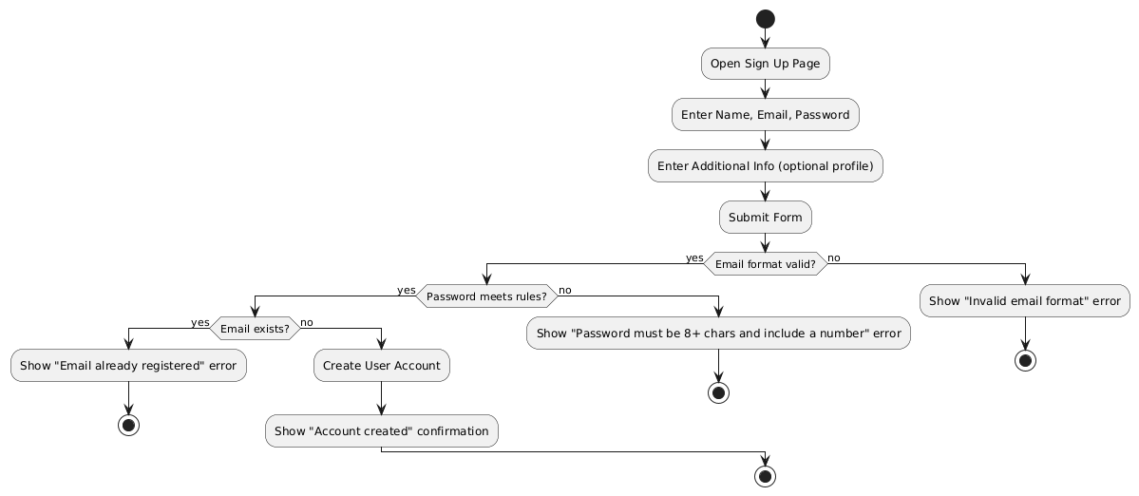 Login - UC002 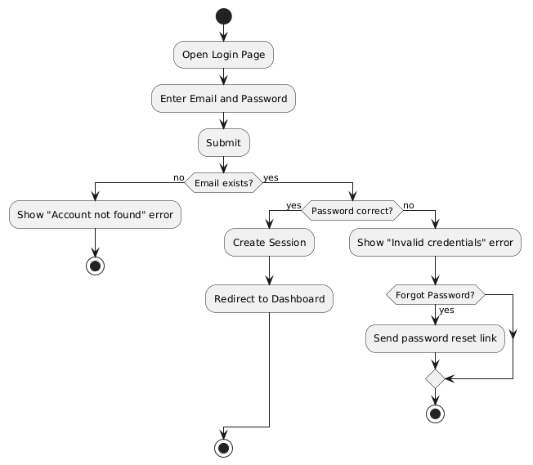

Browse Lessons - UC003

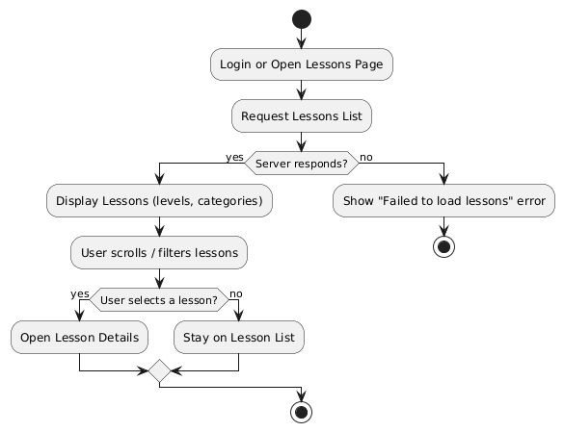

Play Lesson Audio - UC004

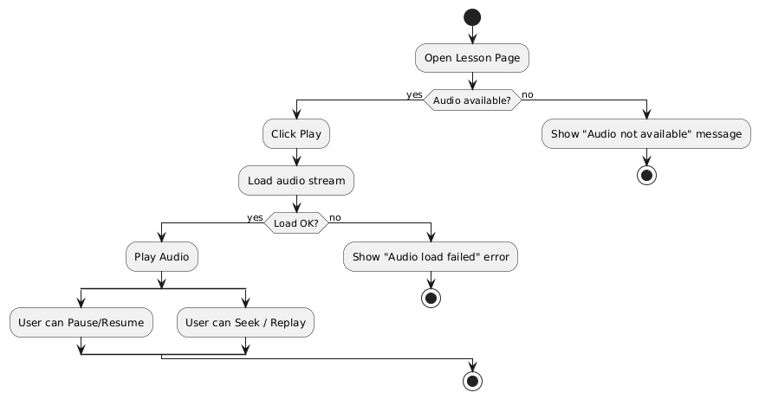

Pronunciation Practice - UC005

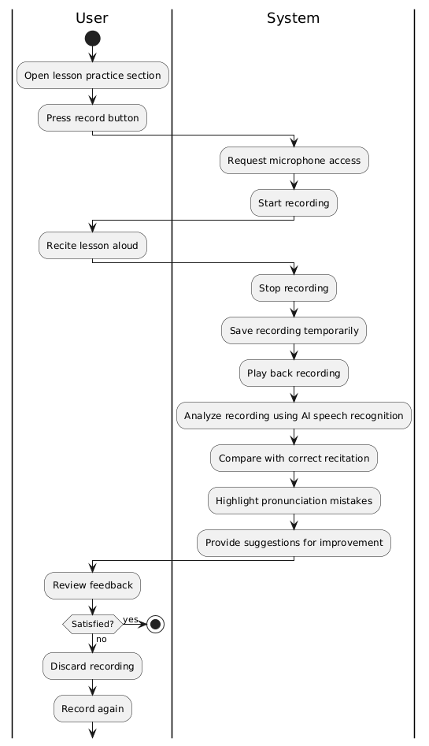

Track Progress - UC006

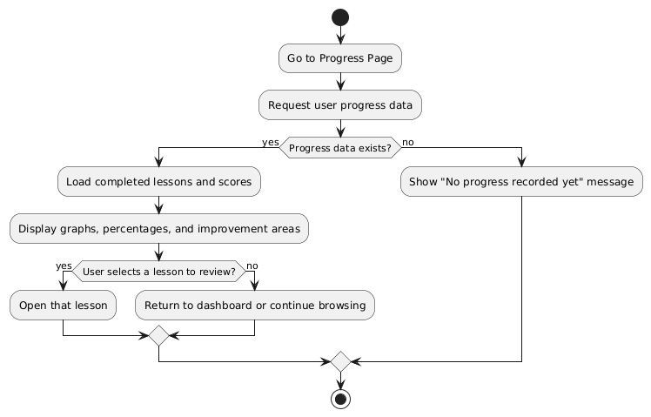

Add new Lessons - UC007

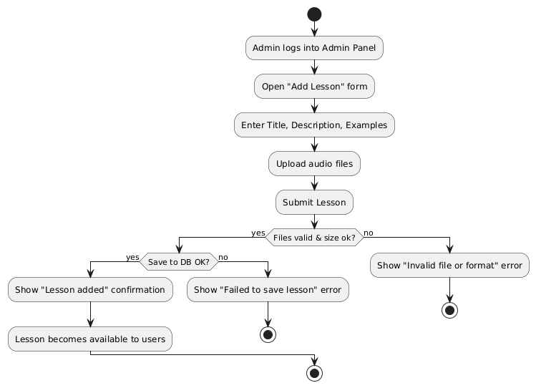

Manage Users - UC008

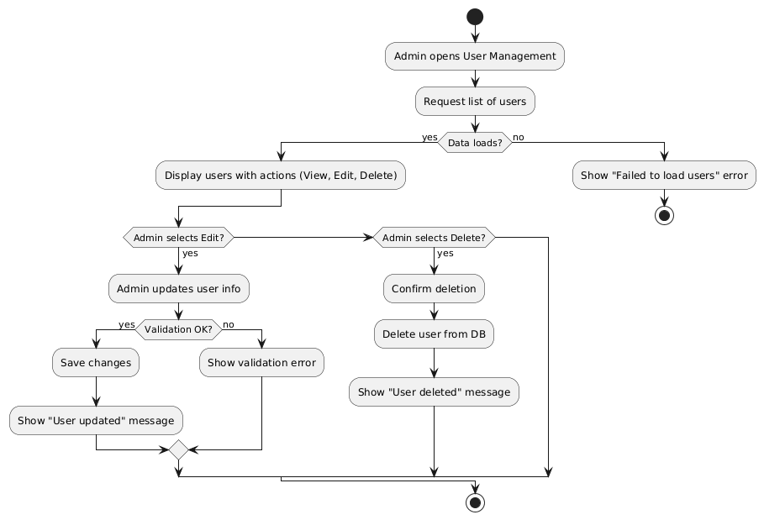

Monitor System Activity - UC009

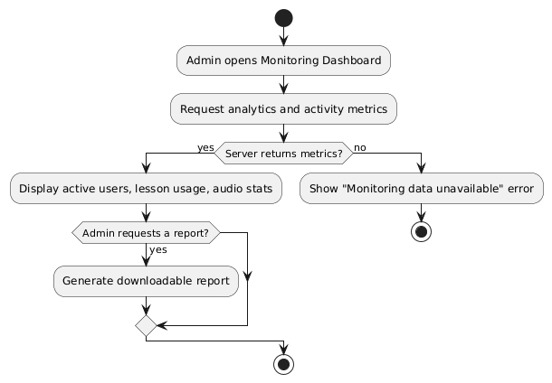
- References
[1] Quran.com, “The Noble Quran – Read, Listen, Search, and Study,” 2024. [Online]. Available: https://quran.com/

[2] Tarteel.ai, “Tarteel – AI Powered Quran Recitation App,” 2024. [Online]. Available: https://tarteel.ai/

[3] Light Upon Light, “Learn Tajweed Online – Quran Tajweed Lessons,” 2023. [Online]. Available: https://lightuponlight.org/

[4] Meta Platforms, “React Documentation,” 2024. [Online]. Available: https://react.dev/

[5] Mozilla Developer Network, “JavaScript Fundamentals,” 2024. [Online]. Available: https://developer.mozilla.org/

[6] PlantUML, “PlantUML Documentation – UML Diagram Guide,” 2024. [Online]. Available: https://plantuml.com/

[7] Al-Huda Institute, “Tajweed Rules and Pronunciation Guidelines,” 2023. [Online]. Available: https://www.alhudapk.com/

[8] ISO/IEC/IEEE, “29148:2021 – Systems and Software Engineering — Requirements Engineering,” 2021.

